R. Reports Menu: A. State Treasurer Fee Report

This report is an exact copy of the form Vermont clerks are required to send to the State Treasurer’s office three times a year. By specifying a date range, this report will show how much money is owed to the state from funds collected when licensing animals.

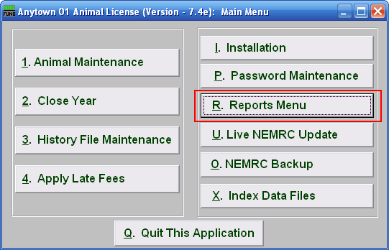
Click on “R. Reports Menu” from the Main Menu and the following window will appear:

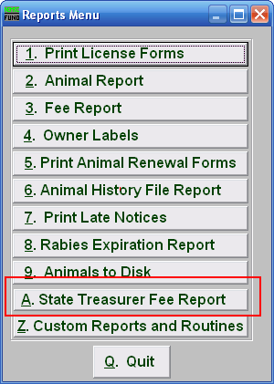
Click on “A. State Treasurer Fee Report” from the Reports Menu and the following window will appear:

State Treasurer Fee Report

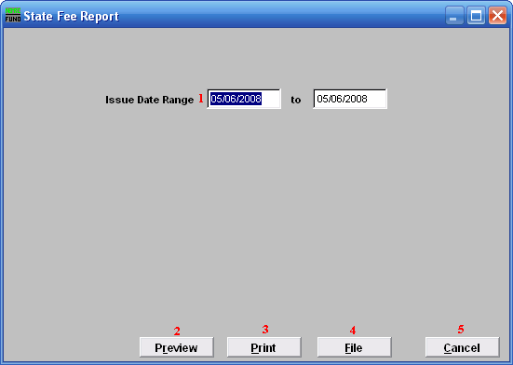
- Issue Date Range: Enter the license issue date range that you want this report to be for.

- Preview: Click this button to preview. Refer to GENERAL PREVIEW for more information.

- Print: Click this button to print. Refer to GENERAL PRINTING for more information.

- File: Click this button to save on this computer. Refer to GENERAL FILE for more information.

- Cancel: Click “Cancel” to cancel and return to the previous screen.

